BHARGAVI .U

21071A6776

**1 .Given a row wise sorted matrix of size R*C where R and** **C** **are always odd, find the median of the matrix.**

#include<bits/stdc++.h>

using namespace std;

int median(int a[][100],int row,int col)

{

int n=row*col;

int arr[n],index=0,i,j;

for(i=0;i<row;i++)

{

for(j=0;j<col;j++)

{

arr[index]=a[i][j];

index++;

}

}

sort(arr,arr+n);

int mid=n/2;

if(n%2==1)

return arr[n/2];

else

return arr[n/2]+arr[n/2+1];

}

int main()

{

int r,c,i,j;

cin>>r>>c;

cout<<"Array elements arex";

int a[100][100];

for(i=0;i<r;i++)

for(j=0;j<c;j++)

cin>>a[i][j];

cout<<"median is :"<<median(a,r,c);

     return 0;

}

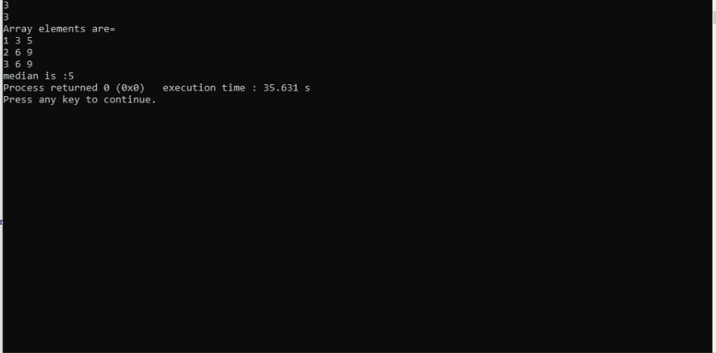

**2. Given the arrival and departure times of all trains that reach a railway station, the task is to find the minimum number of platforms required for the railway station so that no train waits. We are given two arrays that represent the arrival and departure times of trains that stop.**

#include <bits/stdc++.h>

using namespace std;

int ans(int a[],int d[],int n)

{

int min=0,i,j;

for (i=0;i<n-1;i++)

{

int p=1;

for (j=i+1;j<n;j++)

{

if ((a[i]>=a[j] && a[i]<= d[j]) || (a[j]>=a[i] && a[j]<=d[i]))

p++;

}

min = max(min,p);

} return min;

}

int main()

{

int n,i;

cin>>n;

int a[n],d[n];

for(i=0;i<n;i++)

cin>>a[i];

for(i=0;i<n;i++)

cin>>d[i];

cout <<ans(a,d,n);

     return 0;

}

